Design report-turntable
Tao Wang (999020910)
Lining Xie (999021091)
Dongming Zheng (999021371)
Zhuorui Yun (999021264)
Li Yan (999021157)
Abstract
This report presents the mechanical design of a 10-m-diameter turntable for a scientific instrumentation system, focusing on static strength, infinite-life fatigue and positional accuracy under 9.5 tons eccentric payload. Through some assumptions and preliminary calculations, we use quantitative analysis methods to select appropriate standard parts for equipment design, such as the model of bearings and the choice of main steel materials, etc.
Main Design Concept
In this design task, the main difficulty lies in the fact that the equipment rotates while its center of mass does not coincide with the rotation axis. This means that we not only need to take into account the larger mass of 9.5 tons, but also the impact caused by the eccentricity. At the same time, the design also set certain requirements for vertical deflection, horizontal deflection and relative displacement. These factors enabled us to design the following facilities.
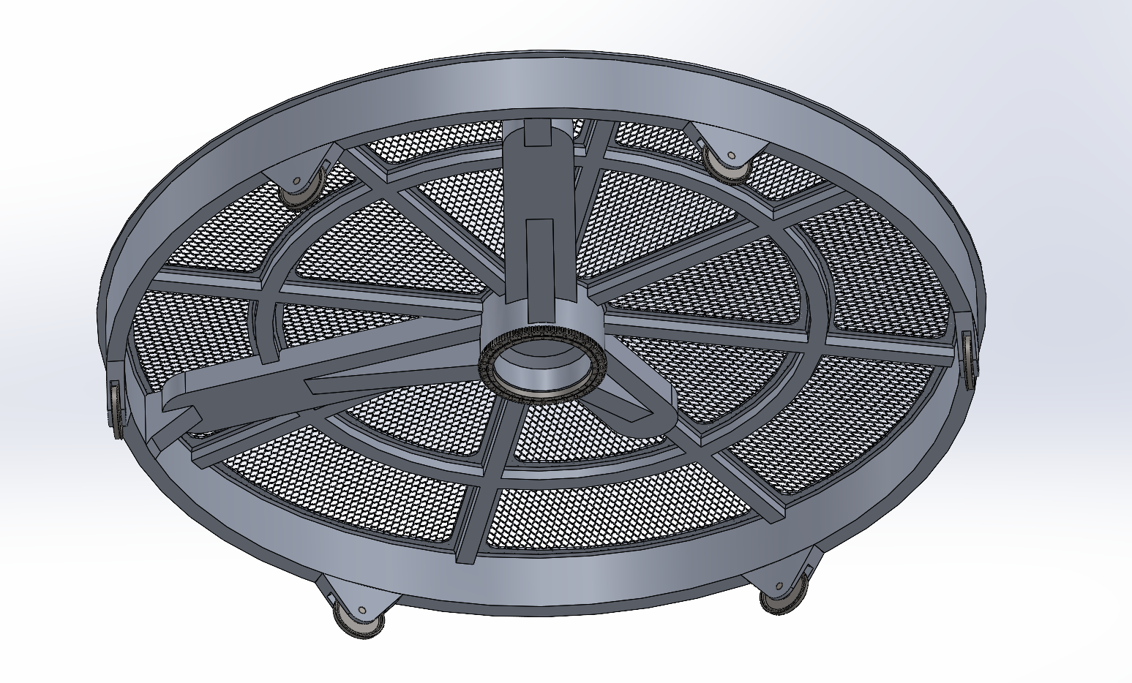
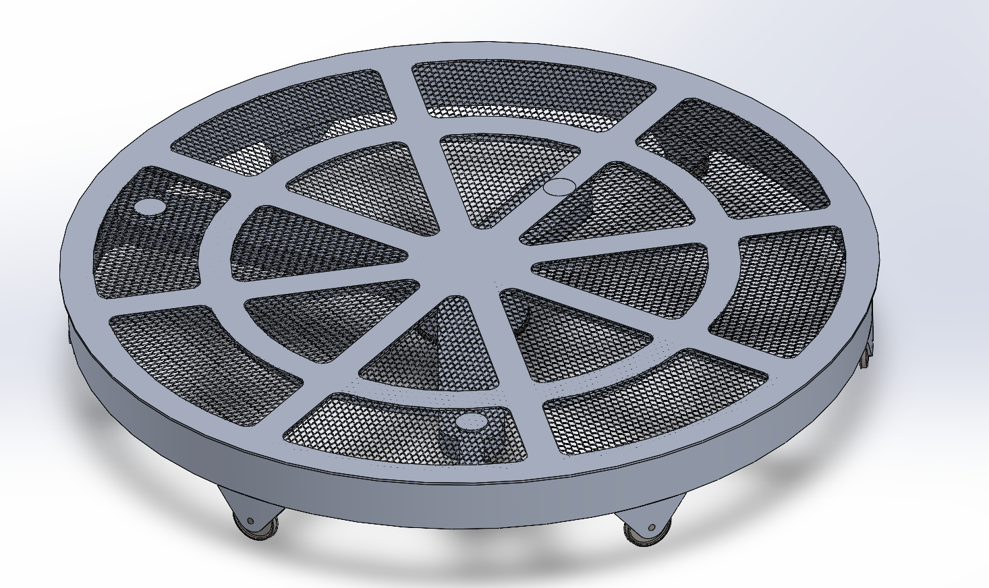
Figure 1. Design main body diagram
Floor design
For the floor that needs to accommodate staff members, we adopted a perforated design and added wire mesh to facilitate the movement of people. This enables us to keep the weight of the floor within approximately 3 tons, meeting the task requirements.
Horizontal shaft design
To meet the more stringent deflection requirements, we employed a beam structure with supports at both ends for support. Use reinforcing ribs to enhance the load-bearing capacity and add chamfers to reduce stress concentration. In the subsequent analysis, we will simplify them to rectangular cross-section beams with both ends fixed to calculate the deflection. (Note: The circular area on the disc is the area where the load is applied.)
Vertical shaft design (main shaft)
Considering that the main shaft has to bear significant bending, gravity and torque, we hope that it can be as short as possible and not be responsible for maintaining the deflection of the disc edge. We will use a special type of industrial bearing - single row cross roller bearings - to connect the main shaft to the ground. The subsequent calculations will verify their validity. This type of bearing can withstand very high loads and bending moments. The rollers’ line-contact design ensures infinite-life performance and simple installation.
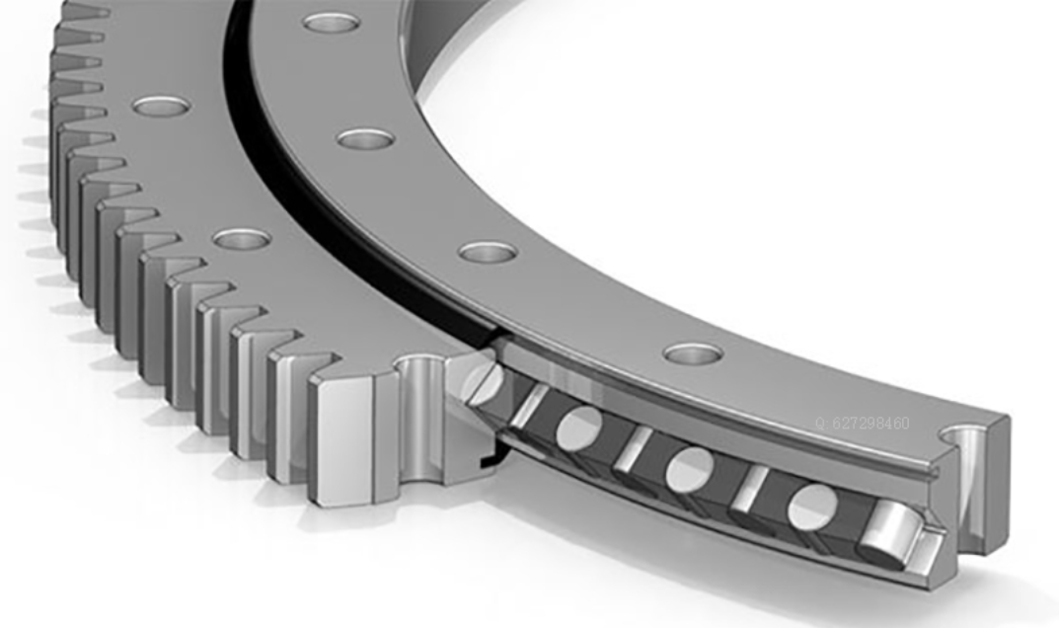
Figure 2. Section diagram of single row cross roller bearing
Edge supporting wheel design
The wheel is very suitable for this design because it can not only support the plane and control the deflection, but also rotate along with the turnplate. The design of the wheels is similar to that of train wheels because their working conditions are similar, and the design can be borrowed from each other.
To connect the wheels to the turntable, bearings are needed. This requires careful selection. We decide to apply spherical roller bearings because they tolerate shaft misalignment and heavy combined loads while offering high radial and axial capacity in a compact envelope; their line-contact design delivers the stiffness and infinite-life performance needed for large, slow-speed turntables, ensuring reliable rotation with minimal maintenance.
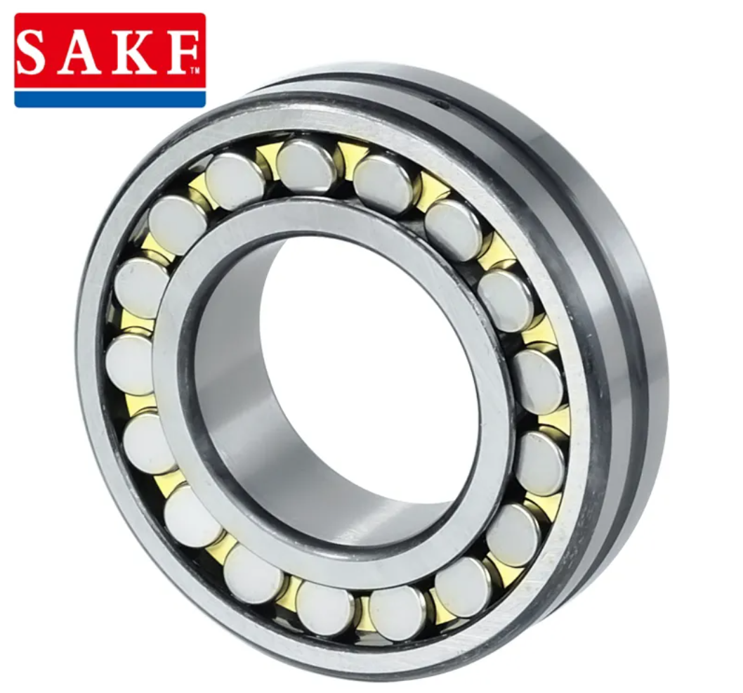
Figure 3. Illustration of self-aligning roller bearing
Quantitative analysis
Deflection
- This section analyzes the structural rigidity of the turntable design to ensure it meets the specified deflection limits under static and dynamic loading conditions.
- Design Configuration: The turntable floor is supported by a structure where the main load-bearing beams are configured as Fixed-Fixed Beams. The beams are rigidly connected to the central hub and the outer rim (which is supported by the bearing/roller system).
- Beam Cross-Section: Rectangular, $800 mm × 300 mm$.
- Material: Aluminum 7075-T6.
  - Young's Modulus $(E ):$ 71.7 GPa.
2. Vertical Deflection Analysis (Static)
2.1 Requirement
- Max Vertical Deflection: < 3.0 mm.
- Max Relative Displacement (Difference): < 500 $μm (0.5 mm).$
2.2 Methodology
The vertical deflection at the mounting points (A, B, C) is calculated using the standard formula for a Fixed-Fixed beam with a concentrated load (weight of the payload) applied at distance $a$ from the center:
$$δ_{z} = \frac{Pa^{3}b^{2}}{3EIL^{3}}, \left(a<b\right)$$
$$δ_{z}= \frac{M_{0}a^{2}b^{2}\left(a-b\right)}{3EIL^{3}} \left(a>b\right)$$
Where:
- $$P = m⋅g ($Gravitational Force).
- $I_{x} = \frac{bh^{3}}{12} = \frac{0.8⋅{0.3}^{3}}{12} = 1.79 ×{10}^{-3} m^{4}$ (Moment of Inertia about the horizontal axis).
- L = 4.6 m (Beam span/Radius).

2.3 Result
Point | Mass (kg) | Radius a (m) | Calculated Deflection δz​ (mm)
A | 3,000 | 3.6055 | 0.018
B | 5,000 | 4.12 | 0.009516
C | 1,500 | 2.00 | 0.0212

2.4 Relative Displacement Check
The maximum difference in vertical displacement between any two points is calculated:
- $|δ_{A} -δ_{B}| = |0.018 - 0.00516| = 0.002373 mm$
- $|δ_{A} -δ_{C}| = |0.018 - 0.0212| = 0.00922 mm$
- $|δ_{B} -δ_{C}| = |0.00516 - 0.0212| = 0.01599 mm$
Result: The maximum relative displacement is $16 μm$, which is significantly below the limit of$500μm$.
3. Horizontal Deflection Analysis (Dynamic)
3.1 Requirement
- Max Horizontal Deflection: The center of the mounting point must not deflect outside a circle of diameter 2 mm (Radius < 1.0 mm).
3.2 Methodology (Worst-Case Scenario)
We analyze the deflection during the maximum acceleration phase at full speed (15 rpm). This generates two horizontal forces:
- Centrifugal Force ($F_{r}):$ Radial outward force.
- Tangential Inertia Force ($F_{t}$): Perpendicular to the radius, caused by angular acceleration ($α$).
Using Point A as the reference example:
- Total Horizontal Force ($F_{total}$): $≈26779.99N$
- Moment of Inertia ($I_{y}$)Resisting horizontal bending, $I_{y}= \frac{h⋅b^{3}}{12}=1.28×{10}^{-2} m^{4}$
3.3 Calculation
Using the fixed-fixed beam model for horizontal load:
$$δ_{h} = \frac{M_{0}L}{12EI}$$
3.4 Vertical Deflection Induced by Moment (Coupling Effect)
Since the mass is located at z=0.5 m (above the beam), the horizontal forces create an overturning moment ($M_{0}$) that twists the beam vertically.
- Moment $M_{0}≈13,390 Nm.$
3.5 Result
Point | Mass (kg) | Radius a (m) | Calculated Deflection δh​ (mm)
A | 3,000 | 3.6055 | 0.043699
B | 5,000 | 4.12 | 0.0095242
C | 1,500 | 2.00 | 0.00154

Result: The maximum relative displacement is $16 μm$, which is significantly below the limit of$500μm$.
Summary: The proposed design using 800mm x 300mm Aluminum 7075 beams in a Fixed-Fixed configuration provides exceptional rigidity. The calculated deflections are orders of magnitude smaller than the allowable limits, ensuring stable operation for the scientific instrumentation payload.

